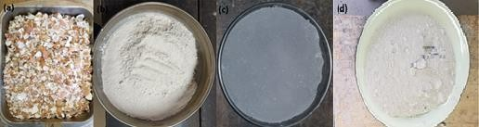
Particulate reinforcements
Sourced eggshells
Milled eggshells
Carbonised eggshells at 800°C;
Fly ash.

